**ALGORITMA STRUKTUR DATA**

**UTS - Praktikum**

**Lavina 2341760062**

Rekening.java

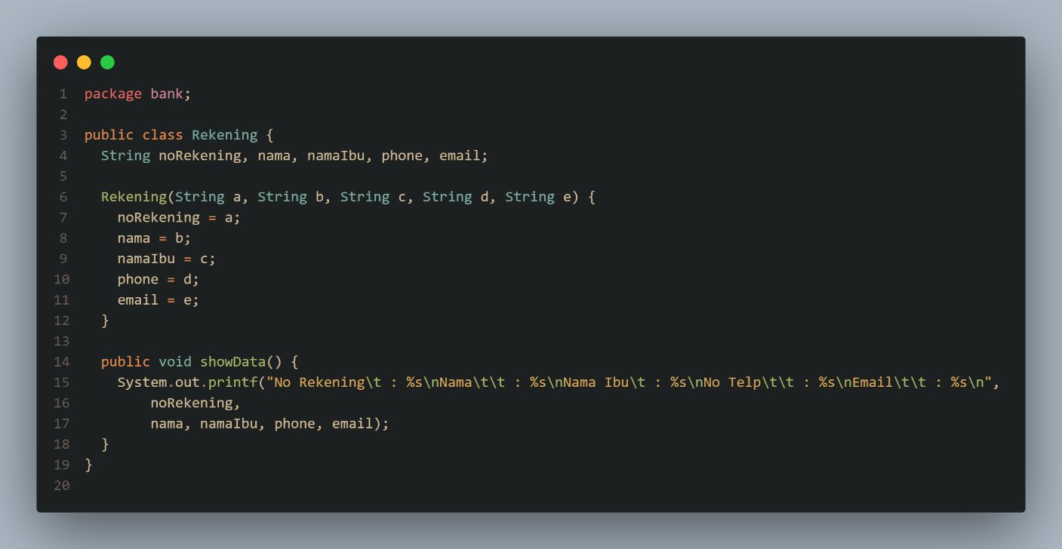

Transaksi.java

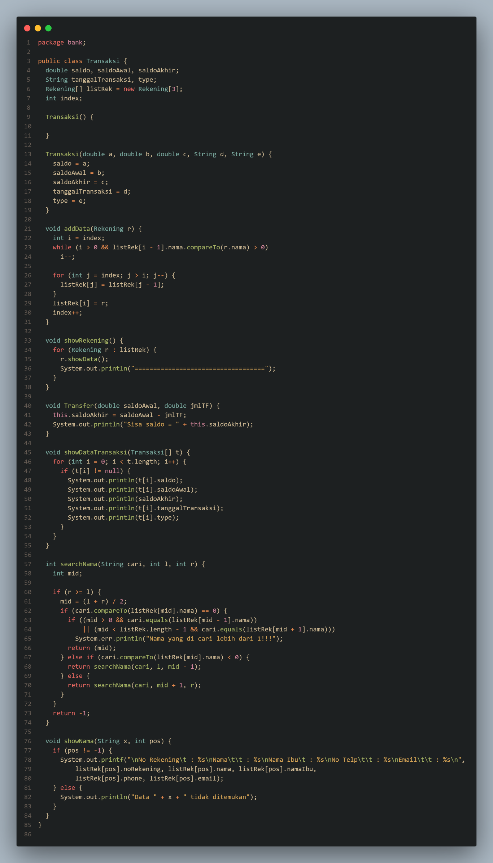

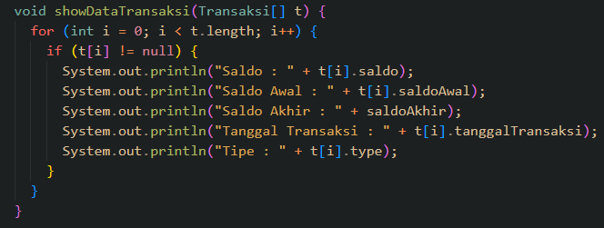

Output:

|  |  |
| --- | --- |
|  |  |
|  |  |

